**SISTEM OPERASI**

**Praktikum 3: Operasi Input Output**

**Lavina 2341760062**

**Percobaan 1: File Descriptor**

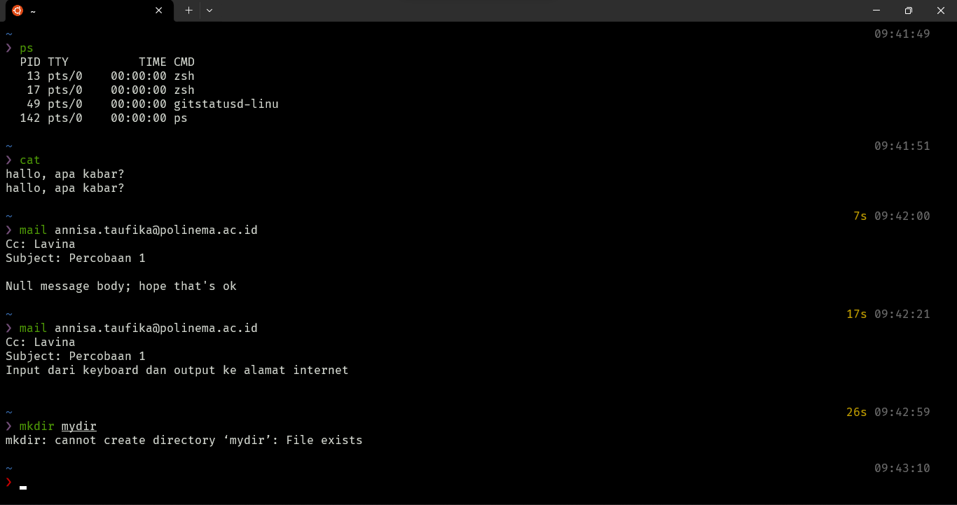

**Percobaan 2: Pembelokan (redirection)**